AI-POWERED MEDICAL LAB REPORT ANALYSIS AND HEALTH INSIGHTS PLATFORM
Conclusion, Future Scope and References
Department of Computer Science and Engineering, TKR College of Engineering and Technology (Autonomous)
Batch A8 (CSE-A) · Academic year 2026-2027
Table 1: Project team
S.No. | Student name | Roll number
1 | BANOTH SWAPNA | 23K91A0528
2 | BEKKAM VARSHITHA | 23K91A0535
3 | A NAVADEEP REDDY | 23K91A0502
4 | BUDIGAM MANOJ | 23K91A0546

Project guide: L.G REDDY
Chapter and section numbers quoted in the text (for example Section 6.6 or Chapter 8) refer to the full project report, 17.Final Document. Figures and tables in this document are numbered from 1.

CHAPTER 9: CONCLUSION

9.1 Summary
The project set out to turn a laboratory report into something a patient can read. It delivers a working system in which an uploaded PDF or image is read, its test rows are extracted, each result is compared with the reference range printed beside it, abnormal results receive a plain-language and non-diagnostic explanation, and everything is stored so that values can be followed over time and two reports compared. A FastAPI service, a React interface, the original Streamlit application, an automated test suite and a reproducible evaluation harness complete the work.

9.2 Objectives achieved
Two of the six objectives were fully met: flagging abnormal results (objective 3) and tracking parameters across reports (objective 5). Four were met in part. Text extraction works for digital PDFs, but the scanned-image path could not be run (objective 1). Field extraction is a regex-and-TF-IDF parser, not the trained NER model the abstract names (objective 2). Explanations are curated rules for 17 tests without retrieval or citations (objective 4). The dashboard exists, but extraction accuracy was measured on generated reports, not on manually labelled real ones (objective 6). Section 8.11 gives the evidence.

9.3 Key findings
• On single-line layouts the parser extracts rows well (F1 about 0.98) and, once a row is read, the range and status are almost always right (99.9% and 99.9%); over all eight layouts of the generated corpus the F1 is 0.916.
• The weak points are specific and fixable: cell-per-line tables (recall 0), a hyphenated date read as a test, a short unit list, and names outside the dictionary that are renamed.
• A plain difflib matcher beat the shipped TF-IDF matcher on noisy names (0.981 against 0.890 at 10% noise), so the choice of TF-IDF is not justified by accuracy.
• The pipeline is fast: a median of 53 ms per text-layer report and about 210 ms for an HTTP upload, far below the 10-second target, although the target was set for scanned input.
• The system is verified by 36 pytest cases and 31 smoke checks (API and browser), all passing.

9.4 Practical applications
• A patient-facing reader that explains in everyday words what a report lists and which values lie outside their range, with a clear disclaimer.
• A library that lets a person keep several reports together and see a test move over months, as the sample data does for haemoglobin and LDL cholesterol.
• A teaching and research scaffold for report digitisation: the generated corpus, the scoring script and the failure analysis can be reused to test a better parser.

9.5 Known limitations
• Layout dependence. On reports where each table cell is a separate text line, the parser extracted no rows at all (recall 0.000 on 210 rows); a date line such as 12-04-2026 was read as a test named "Sample Collected" in every one of the 56 corpus reports that print the date with hyphens.
• Unit gaps. Unit accuracy is 87.1% overall and 57.6% when a flag letter sits between the value and the unit; units such as mg/L, umol/L, ng/dL and uIU/mL are not in the parser's unit list.
• Name matching. The TF-IDF matcher loses accuracy under character noise (89.0% at 10% noise against 98.1% for a plain difflib baseline) and renames some unseen tests, for example Sodium Bicarbonate to Sodium.
• Thin explanation coverage. Only 17 of the 55 dictionary tests (30.9%) have test-specific explanation text; the rest receive a generic paragraph. The explanations are rule-based, with no retrieval and no citations.
• Evaluation data. All accuracy figures come from 120 generated reports (1,680 rows) with generated ground truth, not from real, manually labelled reports. Scanned-image OCR accuracy and latency were not measured because Tesseract was not installed on the test machine, and the optional LLM rewrite was not exercised.
The figures below summarise the measurements behind the conclusions: the first shows extraction quality for each of the eight report layouts of the generated corpus, the second shows how accurately the test-name matcher recovers names under simulated OCR noise.
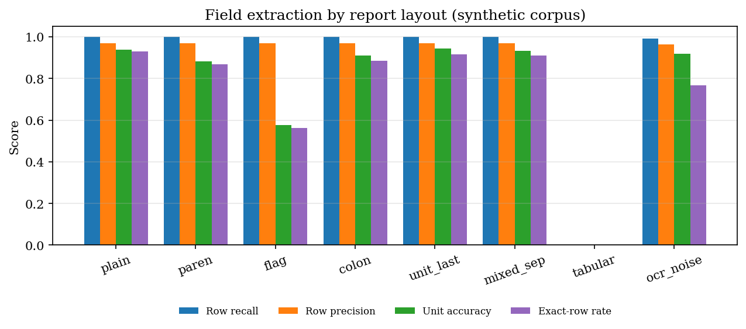
Figure 1: Extraction quality by report layout (generated corpus of 120 text-layer PDFs)
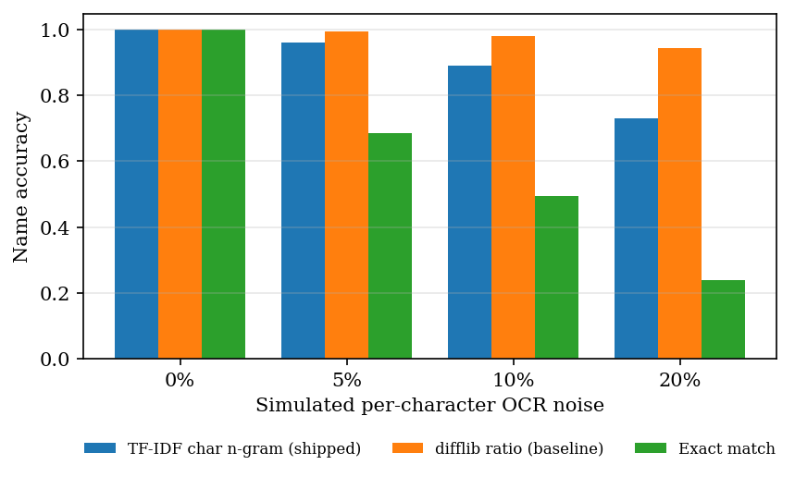
Figure 2: Name accuracy of the shipped matcher and two baselines under simulated noise

CHAPTER 10: FUTURE SCOPE

10.1 Improvements to the extraction
• A table-aware parser. Use word coordinates from the PDF (PyMuPDF can return them) to rebuild rows from cell-per-line tables, closing the 210-row gap measured in Chapter 8.
• Reject date rows. Discard candidate rows whose range holds a year or whose name is a header word, which removes almost every false positive found.
• A full unit table (mg/L, umol/L, ng/dL, uIU/mL and others), and unit detection that tolerates a flag letter between value and unit.
• A synonym table and a safer matcher. Add abbreviations (Hb, TLC, LDL), test a difflib or learned matcher against the TF-IDF one, and refuse to rename names that merely extend a dictionary name.
• Trained entity recognition [14] and a layout-aware OCR engine such as PP-OCR [12] once labelled reports exist, compared with the current parser on the same corpus.

10.2 Better explanations
• Retrieval with citations: a curated, licensed knowledge base with retrieval [6] so that each explanation names its source, as the base paper does [1].
• More tests covered: extend the 17-test knowledge base to the whole dictionary, then rate the text with a clinician.
• Optional LLM rewrite: test it with an API key for quality, cost and failure behaviour.
• Multilingual output for users who read the report in one language and need the explanation in another.

10.3 Evaluation and deployment
• Real, labelled reports. With consent and de-identification, build a small manually labelled set and repeat the extraction experiment on it; evaluate scanned reports and photographs with Tesseract and with PP-OCR.
• Per-user accounts with registration, row-level separation of data and audit logging, replacing the single demo account.
• Deployment: containers, HTTPS, a server database in place of SQLite, and monitoring of failed reports and unmatched names.
• Load and accessibility testing with many users and assistive technology.

10.4 Further research
• Comparing general vision-language models, as in [4], with the parser on the same photographed reports.
• Turning a report into a short list of follow-up actions, as in [3], with safeguards against unsupported claims.
• Trend analysis beyond first-versus-last: slopes, variability and alerts, with the sample date rather than the upload date on the time axis.
• A study of how readers understand and act on the explanations.

REFERENCES
[1] A. Karhade, I. Verma, V. Gadaokar, and J. Mahajan, "RAG-based blood test report analysis to reverse metabolic syndrome," Commun. Appl. Nonlinear Anal., vol. 32, no. 10s, pp. 2771-2779, 2025, doi: 10.52783/cana.v32.5718.
[2] X. Ren, D. Dou, X. He, F. Cui, and J. Zhao, "A serialization method for digitizing the image-based medical laboratory report," Digital Health, 2025, doi: 10.1177/20552076251334431.
[3] S. Xiang, S. Chen, K. Q. Lin, J. Yu, Y. Sun, P. Torr, and A. Atapour-Abarghouei, "Checkup2Action: A multimodal clinical check-up report dataset for patient-oriented action card generation," arXiv:2605.11533, 2026.
[4] N. Bakhsheshi and H. Beigy, "Analysis of blood report images using general-purpose vision-language models," arXiv:2509.06033, 2025.
[5] V.-T. Nguyen, H.-D. Pham, T.-H. To, C.-T. H. Do, T.-T.-T. Dong, V.-T. D. Le, and V.-P. Hoang, "Medalyze: Lightweight medical report summarization application using FLAN-T5-Large," arXiv:2505.17059, 2025.
[6] P. Lewis et al., "Retrieval-augmented generation for knowledge-intensive NLP tasks," in Advances in Neural Information Processing Systems, vol. 33, 2020, pp. 9459-9474.
[7] M. Salvagno, F. S. Taccone, and A. G. Gerli, "Evaluating the feasibility of ChatGPT in healthcare: An analysis of multiple clinical and research scenarios," J. Med. Syst., vol. 47, no. 1, p. 33, 2023.
[8] V. X. Liu, C. A. Sinsky, S. Lin et al., "AI-generated draft replies integrated into health records and physicians' electronic communication," JAMA Netw. Open, vol. 7, no. 3, p. e2417615, 2024.
[9] Y. Shokrollahi, S. Yarmohammadtoosky, M. M. Nikahd et al., "A comprehensive review of generative AI in healthcare," arXiv:2310.00795, 2023.
[10] H.-L. Hsu, C.-T. Dao, L. Wang et al., "MEDPLAN: A two-stage RAG-based system for personalized medical plan generation," arXiv:2503.17900, 2025.
[11] I. Kataria, R. Chadha, and R. Pathak, "Dietary and lifestyle modification in metabolic syndrome: A review of randomized control trials in different population groups," Rev. Health Care, vol. 6, no. 3, pp. 97-103, 2015.
[12] Y. Du, C. Li, R. Guo, X. Yin, W. Liu, J. Zhou, Y. Bai, Z. Yu, Y. Yang, Q. Dang, and H. Wang, "PP-OCR: A practical ultra lightweight OCR system," arXiv:2009.09941, 2020.
[13] R. Smith, "An overview of the Tesseract OCR engine," in Proc. 9th Int. Conf. Document Analysis and Recognition (ICDAR), 2007, pp. 629-633.
[14] J. Lafferty, A. McCallum, and F. Pereira, "Conditional random fields: Probabilistic models for segmenting and labeling sequence data," in Proc. 18th Int. Conf. Machine Learning (ICML), 2001, pp. 282-289.
[15] G. Salton and C. Buckley, "Term-weighting approaches in automatic text retrieval," Inf. Process. Manag., vol. 24, no. 5, pp. 513-523, 1988.
[16] F. Pedregosa et al., "Scikit-learn: Machine learning in Python," J. Mach. Learn. Res., vol. 12, pp. 2825-2830, 2011.
[17] G. Bradski, "The OpenCV library," Dr. Dobb's Journal of Software Tools, 2000.
[18] N. Reimers and I. Gurevych, "Sentence-BERT: Sentence embeddings using Siamese BERT-networks," in Proc. EMNLP-IJCNLP, 2019, pp. 3982-3992.
[19] M. Bayer, "SQLAlchemy," in The Architecture of Open Source Applications, vol. 2, A. Brown and G. Wilson, Eds. 2012.
[20] Artifex Software, "PyMuPDF documentation." [Online]. Available: https://pymupdf.readthedocs.io
[21] S. Ramirez, "FastAPI framework documentation." [Online]. Available: https://fastapi.tiangolo.com
[22] Recharts contributors, "Recharts: A composable charting library built on React components." [Online]. Available: https://recharts.org
[23] Anthropic, "Messages API reference." [Online]. Available: https://docs.anthropic.com
[24] M. Honnibal and I. Montani, "spaCy 2: Natural language understanding with Bloom embeddings, convolutional neural networks and incremental parsing," 2017. [Online]. Available: https://spacy.io
[25] "P-025 Health and safety in medical analysis laboratory," Occupational Medicine, 2024. (Listed in the batch literature survey; authors and details not verified.)
[26] "Analysis of laboratory data of RT-PCR testing for SARS-CoV-2 in SVRDL at Government Medical College, Nagpur," Himalayan J. Community Med. Public Health, 2024. (Listed in the batch literature survey; authors and details not verified.)
[27] "Inter-laboratory study for extraction testing of medical devices," J. Pharm. Biomed. Anal., 2025. (Listed in the batch literature survey; authors and details not verified.)

